**Accounting and Financial Analytics with zoho books**

**Assignment – 4**

**Task 1 – Stock Market Analysis**

**Objective :** Analyzing the performance of MICROSOFT over the past year.

**MICROSOFT**

**INTRODUCTION**

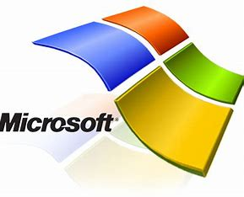

Microsoft Corporation is an American multinational corporation and technology company headquartered in Redmond, Washington.[2] Microsoft's best-known software products are the Windows line of operating systems, the Microsoft 365 suite of productivity applications, and the Edge web browser. Its flagship hardware products are the Xbox video game consoles and the Microsoft Surface lineup of touchscreen personal computers. Microsoft ranked No. 14 in the 2022 Fortune 500 rankings of the largest United States corporations by total revenue;[3] and it was the world's largest software maker by revenue in 2022 according to Forbes Global 2000. It is considered one of the Big Five American information technology companies, alongside Alphabet (parent company of Google), Amazon, Apple, and Meta (parent company of Facebook).

Microsoft was founded by Bill Gates and Paul Allen on April 4, 1975, to develop and sell BASIC interpreters for the Altair 8800. It rose to dominate the personal computer operating system market with MS-DOS in the mid-1980s, followed by Windows. The company's 1986 initial public offering (IPO) and subsequent rise in its share price created three billionaires and an estimated 12,000 millionaires among Microsoft employees. Since the 1990s, it has increasingly diversified from the operating system market and has made several corporate acquisitions, the largest being the acquisition of Activision Blizzard for $68.7 billion in October 2023,[4] followed by its acquisition of LinkedIn for $26.2 billion in December 2016,[5] and its acquisition of Skype Technologies for $8.5 billion in May 2011.[6]

**Key businesses**

1.Hardware Products : Microsoft has produced a variety of hardware products over the years.

* Microsoft Surface Devices: Microsoft's line of touchscreen-based personal computers and interactive whiteboards, including the Surface Pro, Surface Laptop, Surface Book, Surface Studio, and Surface Hub.
* Xbox Gaming Consoles: Microsoft's gaming consoles, including the Xbox, Xbox 360, Xbox One, and Xbox Series X/S.
* Microsoft Keyboards and Mice: Various keyboards and mice designed for use with computers, including ergonomic models and gaming peripherals.
* Microsoft Surface Accessories: Accessories for Surface devices such as Surface Pen, Surface Dial, Surface Arc Mouse, and Surface Dock.
* Microsoft Webcams: Products like the LifeCam series offering webcams for personal and business use.
* Microsoft Surface Earbuds: Wireless earbuds designed for productivity and comfort.

2.Software Products : Microsoft is known for developing a wide range of software products across various categories.

* Windows Operating Systems: Microsoft Windows is one of the most widely used operating systems for personal computers and servers. Versions include Windows 11, Windows 10, Windows 8, Windows 7, and earlier iterations.
* Microsoft Edge: A web browser developed by Microsoft, initially introduced as the replacement for Internet Explorer.
* Visual Studio: An integrated development environment (IDE) used to develop computer programs, websites, web apps, and mobile apps. It supports multiple programming languages including C#, C++, Visual Basic, and more.
* SQL Server: A relational database management system (RDBMS) developed by Microsoft. It is used for storing and retrieving data as requested by other software applications.
* Microsoft Teams: A collaboration platform that combines workplace chat, video meetings, file storage, and application integration.
* Microsoft Dynamics 365: A suite of enterprise resource planning (ERP) and customer relationship management (CRM) applications.
* Power BI: A business analytics service provided by Microsoft for interactive visualizations and business intelligence capabilities.

3. Services : Microsoft provides a variety of services aimed at individuals, businesses, developers, and IT professionals. Some of the key Microsoft services include:

* Microsoft 365: A subscription service that includes access to Office applications (Word, Excel, PowerPoint, Outlook, etc.), cloud storage with OneDrive, collaboration tools with Teams, and security features.
* Azure: Microsoft's cloud computing platform, offering Infrastructure as a Service (IaaS), Platform as a Service (PaaS), and Software as a Service (SaaS) solutions. Azure provides computing, storage, analytics, machine learning, and other cloud services.
* Xbox Live: An online gaming service for Xbox consoles, providing multiplayer gaming, digital game purchases, free games through Games with Gold, and other features.
* Microsoft Dynamics 365: A suite of enterprise resource planning (ERP) and customer relationship management (CRM) applications, offering solutions for sales, customer service, finance, operations, and more.
* Microsoft Advertising: An advertising platform that allows businesses to create and manage advertising campaigns across Microsoft's properties, including Bing, MSN, Outlook.com, and the Microsoft Audience Network.

4.Retail : Microsoft has operated retail stores in various locations around the world, offering customers the opportunity to experience and purchase Microsoft products and services firsthand. The Microsoft Store concept was introduced to provide a physical space for customers to interact with Microsoft's hardware, software, and devices in an immersive environment. These retail stores typically offer a range of products, including Surface devices, Xbox consoles and games, Windows PCs, Microsoft Office software, and various accessories.

5. Content and Media Production :

Microsoft has engaged in various content and media production initiatives over the years. While not primarily known as a content production company like traditional media companies, Microsoft has created and acquired content for different purposes, including entertainment, education, and marketing.

**DATA ANALYSIS**

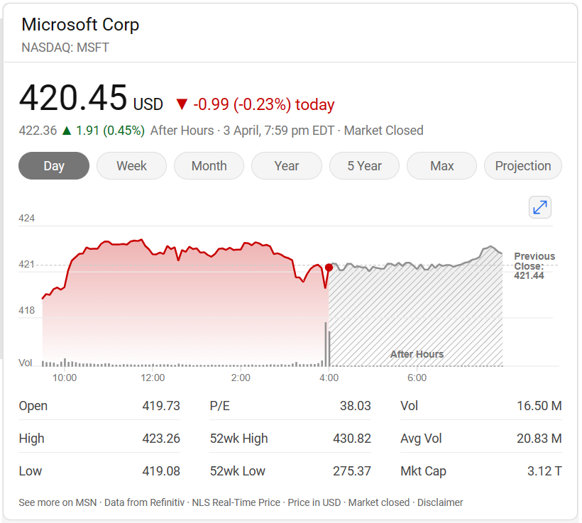

**Historical price data**

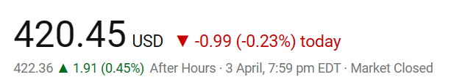

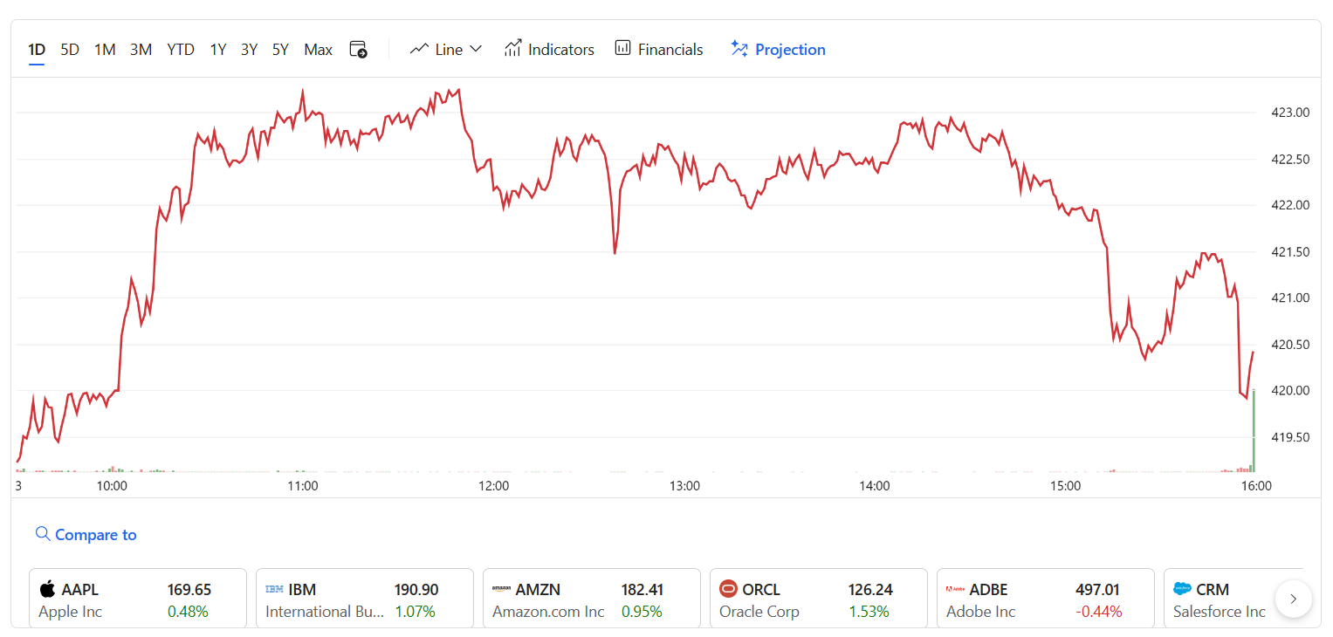

**historical stock price data chart**

**Key metrics**

Microsoft tracks a range of key metrics to assess the performance and success of its business across various segments. Some of the key metrics commonly used by Microsoft include:

1.Revenue: Total revenue generated from product sales, subscriptions, and services across different business segments, including Productivity and Business Processes, Intelligent Cloud, and More Personal Computing.

2.Operating Income: The income generated from Microsoft's core business operations after subtracting operating expenses.

3.Net Income: The total profit after subtracting all expenses, including operating expenses, taxes, and interest.

4.Revenue Growth: The rate of increase in revenue over a specified period, indicating the company's ability to grow its top line.

5.Gross Margin: The percentage of revenue remaining after subtracting the cost of goods sold (COGS). A high gross margin indicates efficient production and pricing strategies.

6.Operating Margin: The percentage of revenue remaining after subtracting operating expenses. It measures the efficiency of Microsoft's operating activities.

**Historical annual stock price data**

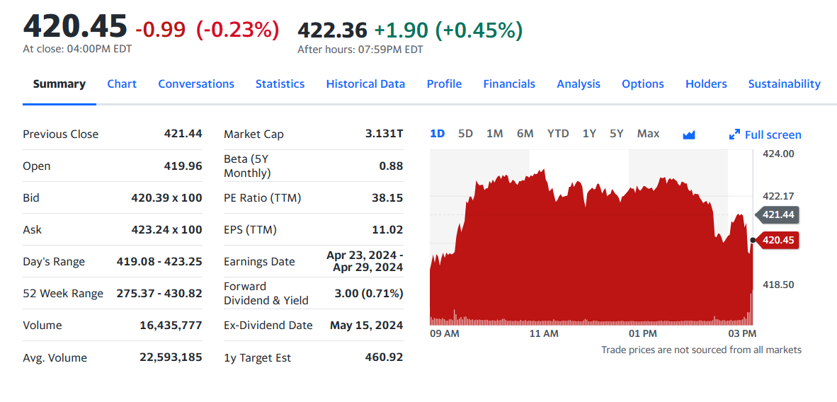

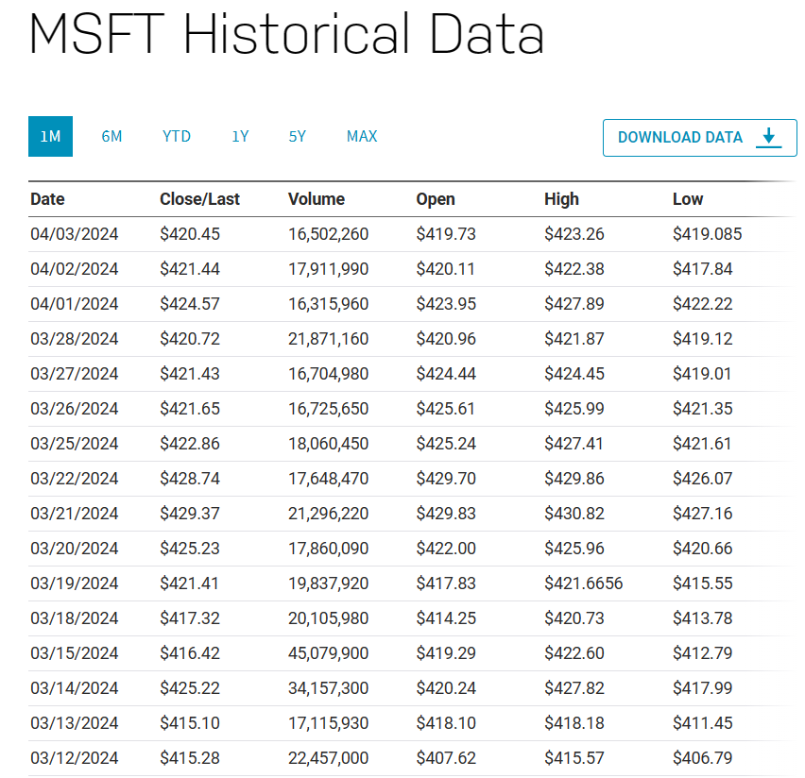

**Stock price change chart**

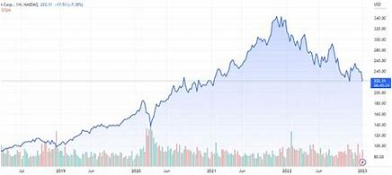

**Volatility**

The stock price has increased by +52.86% in the last 52 weeks. The beta is 0.89, so Microsoft's price volatility has been lower than the market average.

The historical volatility of MSFT stock over the past decade has varied significantly.

Here’s a summary of the annual standard deviation (a common indicator of volatility) for MSFT:

2014: 3.07

2015: 4.03

2016: 3.79

2017: 6.88

2018: 7.84

2019: 14.74

2020: 22.72

2021: 36.72

2022: 24.95

2023: 41.36 (the highest volatile year)

Notably, 2023 experienced significant price variations, making it a turbulent year for MSFT1.

**Standard deviation**

Standard deviation, a popular indicator of volatility is a measure of oscillation (think a stock graph) of a stock against the average. In simple terms, higher the volatility for a time period, greater will be the price variations during that period. Generally high volatile stocks are less predictable and vice versa.

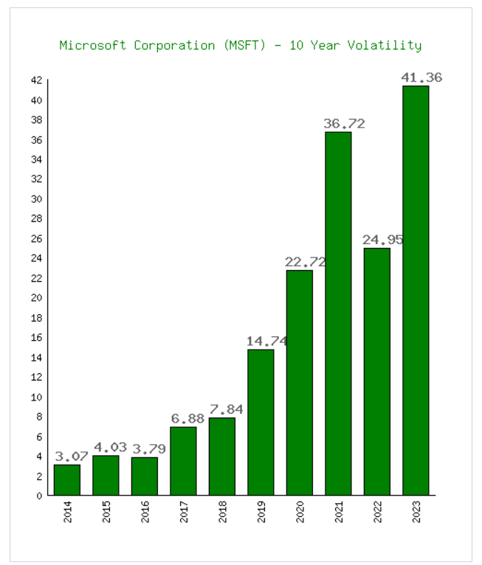

**Average trade volume**

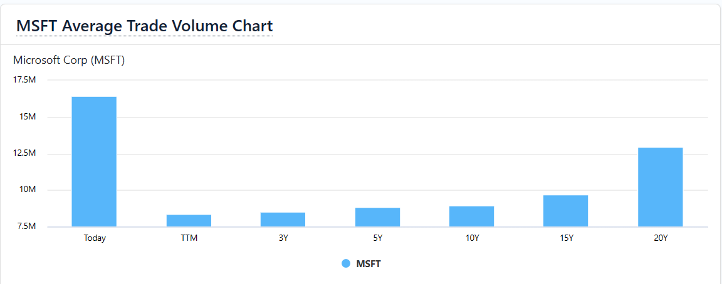

**Stock comparison and analysis**



vs

|  |  |  |  |  |  |  |  |  |  |  |  |
| --- | --- | --- | --- | --- | --- | --- | --- | --- | --- | --- | --- |
| Symbol | | MSFT | | NFTY | |  | |  | |  | |
| Company | | MICROSOFT CORP | | FT India Nifty 50 EW ETF | |  | |  | |  | |
| **Price Information** | |  | | | | | | | | | |
| Exchange | | NASDAQ | | NASDAQ | |  | |  | |  | |
| Open | | 419.73 | | 57.13 | |  | |  | |  | |
| High | | 423.26 | | 57.29 | |  | |  | |  | |
| Low | | 419.08 | | 56.86 | |  | |  | |  | |
| Last | | 420.45 | | 57.29 | |  | |  | |  | |
| Change | | -0.99 | | + 0.28 | |  | |  | |  | |
| % Change | | -0.23% | | + 0.49% | |  | |  | |  | |
| Volume | | 16,502,201 | | 50,100 | |  | |  | |  | |
| 20-Day Average Volume | | 20,741,789 | | 33,595 | |  | |  | |  | |
| Previous Close | | 421.44 | | 57.01 | |  | |  | |  | |
| Industry | | Computer - Software | | N/A | |  | |  | |  | |
| Has Options | | Yes | | Yes | |  | |  | |  | |
| **Technicals** | |  | | | | | | | | | |
| 20-Day Moving Average | | 418.46 | | 56.63 | |  | |  | |  | |
| 20-Day Raw Stochastic | | 68.02% | | 67.01% | |  | |  | |  | |
| 20-Day Relative Strength | | 55.43% | | 57.38% | |  | |  | |  | |
| Weighted Alpha | | +43.77 | | +33.61 | |  | |  | |  | |
| Today's Opinion | | 100% Buy | | 96% Buy | |  | |  | |  | |
| Previous Opinion | | 100% Buy | | 88% Buy | |  | |  | |  | |
| Last Month's Opinion | | 100%Buy | | 100%Buy | |  | |  | |  | |
| **Performance** | |  | | | | | | | | | |
| **5-Days** | |  | | | | | | | | | |
| %Chg | | -0.28% since 03/26/24 | | +2.30% since 03/26/24 | |  | |  | |  | |
| Low | | 417.84 on 04/02/24 | | 55.92 on 03/27/24 | |  | |  | |  | |
| High | | 427.89 on 04/01/24 | | 57.46 on 04/01/24 | |  | |  | |  | |
| **1-Month** | |  | | | | | | | | | |
| %Chg | | +1.19% since 03/01/24 | | -0.09% since 03/01/24 | |  | |  | |  | |
| Low | | 398.39 on 03/06/24 | | 55.34 on 03/19/24 | |  | |  | |  | |
| High | | 430.82 on 03/21/24 | | 58.25 on 03/08/24 | |  | |  | |  | |
| **3-Month** | |  | | | | | | | | | |
| %Chg | | +13.45% since 01/03/24 | | +5.76% since 01/03/24 | |  | |  | |  | |
| Low | | 366.50 on 01/05/24 | | 53.37 on 01/23/24 | |  | |  | |  | |
| High | | 430.82 on 03/21/24 | | 58.25 on 03/08/24 | |  | |  | |  | |
| **6-Month** | |  | | | | | | | | | |
| %Chg | | +34.16% since 10/03/23 | | +18.98% since 10/03/23 | |  | |  | |  | |
| Low | | 314.00 on 10/04/23 | | 46.60 on 10/26/23 | |  | |  | |  | |
| High | | 430.82 on 03/21/24 | | 58.25 on 03/08/24 | |  | |  | |  | |
| **Key Statistics** | |  | | | | | | | | | |
| Market Capitalization, $K | | 3,131,483,520 | | 191,922 | |  | |  | |  | |
| Shares Outstanding, K | | 7,430,437 | | 3,350 | |  | |  | |  | |
| Annual Sales | | 211,915,000,000 | | 0 | |  | |  | |  | |
| Annual Net Income | | 72,361,000,000 | | 0 | |  | |  | |  | |
| Last Quarter Sales | | 62,020,000,000 | | N/A | |  | |  | |  | |
| Last Quarter Net Income | | 21,870,000,000 | | N/A | |  | |  | |  | |
| 60-Month Beta | | 0.89 | | 0.72 | |  | |  | |  | |
| **Per-Share Information** | |  | | | | | | | | | |
| Most Recent Earnings | | 2.93 on 01/30/24 | | N/A | |  | |  | |  | |
| Latest Earnings Date | | 04/23/24 | | N/A | |  | |  | |  | |
| Most Recent Dividend | | 0.750 on 02/14/24 | | 0.079 on 03/21/24 | |  | |  | |  | |
| Next Ex-Dividends Date | | 05/15/24 | | 03/21/24 | |  | |  | |  | |
| **Ratios** | | **05/15/24** | | | | | | | | | |
| Price/Earnings ttm | | 38.39 | | 17.01 | |  | |  | |  | |

**Key events of Microsoft**

Microsoft, being one of the largest technology companies in the world, has had numerous key events throughout its history. Here are some significant milestones and events in Microsoft's journey:

1.Foundation of Microsoft (1975): Bill Gates and Paul Allen founded Microsoft on April 4, 1975, in Albuquerque, New Mexico. Initially, the company developed programming language software for the Altair 8800 microcomputer.

2.MS-DOS (1980): Microsoft purchased the rights to QDOS (Quick and Dirty Operating System), which later became MS-DOS (Microsoft Disk Operating System). MS-DOS became the foundation for Microsoft's success in the personal computer industry.

3.Microsoft Windows (1985): Microsoft released its first version of Windows, Microsoft Windows 1.0, providing a graphical user interface (GUI) for IBM-compatible PCs. Windows eventually became the dominant operating system for personal computers worldwide.

4.Microsoft Office Suite (1989): Microsoft launched Microsoft Office, a suite of productivity software including Word, Excel, and PowerPoint. Office became one of Microsoft's flagship products and a standard in business and personal computing.

5.Windows 95 (1995): Microsoft released Windows 95, a significant update to its operating system featuring the Start menu, Taskbar, and Plug and Play capabilities. It was a major milestone in the evolution of Windows and helped Microsoft solidify its dominance in the PC market.

6.Internet Explorer (1995): Microsoft launched Internet Explorer 1.0, its web browser, as part of Windows 95. Internet Explorer became the dominant web browser in the late 1990s and early 2000s.

7.Microsoft Office 365 (2011): Microsoft introduced Office 365, a subscription-based version of its Office productivity suite, offering cloud-based storage and collaboration features. It marked Microsoft's shift towards cloud computing and subscription-based services.

8.Windows 10 (2015): Microsoft released Windows 10, the latest version of its operating system, introducing new features such as Cortana, the Microsoft Edge browser, and the return of the Start menu. Windows 10 was positioned as a service rather than a standalone product, with regular updates and feature enhancements.

9.Acquisition of LinkedIn (2016): Microsoft acquired LinkedIn, the professional networking platform, for $26.2 billion. The acquisition was aimed at integrating LinkedIn's social network with Microsoft's productivity tools and cloud services.

10GitHub Acquisition (2018): Microsoft acquired GitHub, the leading software development platform, for $7.5 billion. GitHub continues to operate independently but benefits from Microsoft's resources and integration with its development tools and services.

***

**M. Triveni**